# Loffa E-Signature E-Mail with/portal-link for simple S-Side form access.

## **Scope Document**

This specification applies to FVD-S only for now. The goal is to develop as a micro-service that can be called upon to perform similar functionality for all applications in the future. (PBIN and QBS).

*Dev to add convention information (how to setup environment, code type, naming conventions, etc). This form page does have to be located in it’s own dedicated IIS site.*

**Assumption**: We have instructions to send to a LOFF to an email address. (Not a fax, and not in-network)

**Scenario 1:** (*file import*):

1. The handler gets to a record in which the destination instructions has been determined to have an email address for the destination. The email **cannot** be for @efaxsend.com.
2. The handler processes the record into the FVD-S side database as it always has, creates the db record, updates all as always. But instead of kicking off an email with PDF it does (see #3 below).
3. The handler generates an email with a link back to the form (this “form” doesn’t exist today).
   1. The recipient will receive an email with a link to the form.
      1. The specifics of the email to be determined (Subject, content) by using existing email content (excluding the attachment). Starting point -dial in the spec of the email as we go through testing.
   2. The recipient can forward to the email to another party for response. Keep in mind the recipient is often a distribution list or group email.
   3. The recipients will receive a reminder to respond if link not clicked after D+3 & D+6.
      1. The 2nd and third emails are to have new “links url’s” to reduce security footprint of the link being active for the entire 7 days. The link is unique each time.
      2. Client settings allows the customer to set a preference of “attach the PDF” PDF in either the 1st, or the 2nd email as an attachment copy of the PDF for recipient to have both ways of compliance to the signature.
         1. Default setting would be the PDF is not attached -only link.
         2. The Preference setting can be per DTC destination.
            1. You can override and attach PDF on 1st or 2nd email.
            2. The handler would have to check this preference to determine if it generates and attaches the PDF in the email that is sent with the link.
         3. There needs to be an option to set preference for all to be PDF’s instead of a time sensitive portal link.
      3. The handler does this “resend” process now, looking for records that have not been completed. We are hijacking this process of the Handler looking for T+3 resends.
      4. We will not know if they elected to use the attachment, if they save the attachment and sign it, and send it back in. We will only know when the handler receives it in the inbox and processes it to close out the request (refid=refid). This needs to invalidate the link at this time because the record is closed.
   4. There is no security on the link except that it’s an obscure random GUID and only active for D+7 days (renewed every 3 days -only the same URL for 3 days max).
4. The Database will track the following:
   1. To state the obvious, the link is recorded in the database to match back to the form that needs to be pulled up later.
   2. The date-time when the original email was sent (already does this in the handler).
   3. The date-time of any activity performed on the email -if possible.
      1. Email Opened/Accessed by Whom with Date/Time -if possible.
      2. Link is clicked (track that activity -audit).
      3. Forwarded -If possible
      4. Deleted – If Available
      5. Form is Submitted
   4. The destination of the where the email was sent.
   5. The destination of the where the email was forwarded. If Available
5. The Workflow:
   1. Once Recipient Checks appropriate box and responds the Record/Ref ID is marked.
   2. If a different representative at the recipient goes to access a completed LOFF they will see the response. Similar to QuickBooks Invoice process. (remember, this is an **unauthenticated time sensitive link** they clicked on, the page is available to anyone that knows the guid).
      1. If someone clicks on the link and the form has already been submitted, it says it’s closed (no form, no links except for marketing links to marketing pages).
      2. If someone clicks on the link and the link is expired (see t+3) then they see please find updated link in new email message.
         1. This message needs to be dialed-in, can be done during testing phase.
         2. Initial scope just needs placeholder.
   3. After the form is later submitted a column will be updated that will keep the form from being able to be displayed again. Invalidating the link.
   4. If the link is accessed more than once before the form is submitted, the link is made invalid and an email is re-generated to the original recipient with a new link to the form. The email informs them that the link can only be used by them. Not to click on it if they are forwarding to someone else to complete.
      1. Once the link has been clicked on, the link is only valid for 24 hours (state this on the form). If it expires the follow-up email goes with new URL.
6. Invalidating links.
   1. A link can become invalid if.
      1. 3 days goes by after being sent and no one has submitted the form.
         1. A new URL is created and sent (new guid).
      2. 6 days goes by after being sent and no one has submitted the form.
         1. A new URL is created and sent (new guid).
      3. 7 days, the link is made invalid, no new link is sent.
      4. The link is clicked on, but not submitted within 24 hours.
         1. A new URL is created and sent (new guid).
            1. This requires the handler to check for this condition.
7. User receives an email, the link within that takes the user to the e-signature form. Again, it appears just like the R-Side FVD form. To reiterate, this URL is to be a dedicated site, not part of the existing FVD code. The link can point to verifiy.loffa.com for example. The idea being that we do not expose the existing FVD site/code to non-authenticated access.

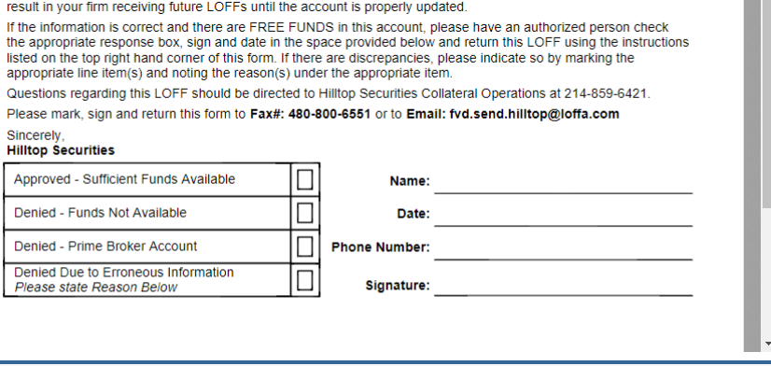

1. The user is able to check a box if approved or declined, they can then “sign” the form and place their signature, date etc, in the form.
2. The recipient submits the form, this initiates the following:
   1. It invalidates the original link. D+3 to D+6, Expire on D+7
   2. We will send the Counterparty a copy of the stamped FORM (Time/Tape on the Items)
   3. It asks the user to sign-up and shows a sample image of a “portal enabled” account where the S-Side customer can see multiple LOFFS that have been sent to them, with their statuses and ability to download/sort etc.
   4. If they elect to “sign up” it just **sends an email** to sales for now, later, once account creation is automated, it will allow them to finish setting up their R-Side loffa account.
   5. There is a PDF, and the signature file. Submission of the form also updates the S-Side record or course with the correct status and stores the signature they used so it can be embedded later when viewing the LOFF. No PDF is generated in this scenario. PDF’s can be generated via the app when requesting to save out the record. This is a Straight Through Processing update, just like S-Side to R-Side participate to participant transaction.
      1. The SP’s to update the record already exist.
      2. The forms already exist.
      3. We would need to store the embedded signature that the recipient used.
      4. When do we send the original recipient a copy of the PDF (why not use that copy as what we store to use for later for our eom reports etc.).
         1. The signature solution we use will likely have this.
         2. We have a requirement to hold into the WORM a copy of the PDF, so a PDF file is necessary.
      5. The signature is saved and used in a cookie.
         1. Upon submission the recipient will put in their name, email, and that information will be stored in a cookie.
         2. We will set the expiration of the cookie to 5 days.
         3. The recipient will not need to re-add their name/email each submission, but each week.
         4. When they click on the link, the form needs to state that we track cookies. If they don’t accept the cookie they add name each time.
         5. When they “Sign” the form, they create their “signature” and it is stored and called out later by using the cookie session info so they can just “sign” and the signature image appears without re-doing that. But again, re-do each week.
   6. Once the recipient does submit the completed form the S-Side database is, of course, updated where the link information is stored to invalidate the link and mark it as completed.
3. No record is kept on the “R-Side Non-Customer” for what was sent to the recipient, there is no R-Side database in this scenario. They have no dedicated database of their own. they are to be thought of as a non-participant R-Side “recipient”. All they are accessing when they click the link is the exposed R-Side form of the paying S-Side Loffa client. The URL points to the same **domain** as the S-Side application, but not the same site IE: verification.**loffa.com**. The fact that it was sent and signed is stored in the S-Side database for the client that sent the request.
   1. The database for the S-Side already exists.
   2. The tables for what was sent already exist.
   3. The SP’s to update the record with status already exists.
   4. All that would need to be needed is the tracking and auditing of the usage of the link that takes the recipient to the form. A table is added to store the fact that link that was generated was clicked on, is now not active, and was completed.
4. The sender (what the S-Side sees when they login to FVD).
   1. When the sender logs in they will see records that were sent via “portal” as a new method of sending.
   2. They will see completed LOFF’s.
      1. When they click on a completed Loff that was signed by the recipient from the portal, they will see a digital copy of the Form by way of a web form (not a PDF). -is this true since we have a PDF.
      2. They will see the signature file embedded over the form where it was placed.
      3. They will see the form is updated with decline or approved status and signature.
      4. They will be able to save the record out as a PDF is they wish (by downloading the PDF).
      5. Make it clear that it was signed digitally by the portal
   3. They will see unfinished LOFF’s (those that were sent out but not “signed”).
      1. They can see any autom re-sent reminder emails that went out (or the count)
         1. We are tracking how many times the link is sent.
   4. The activity manager will need a new filter type to include portal e-signature requests sent and signed.

**New tables:**

[Link-Generated]

LinkID RecordID idLinkSent

isActive isComplete DateTimeCompleted

SignatureFilePath NumberOfTimesSent guid

[Link-GeneratedTimes]

linksentID Idlink datetimesent

**Scenario 2** (compose).

The same steps apply, instead of the handler generating the initial email with link the site must kick off the email and generate/embed the link in the email.

Hopefully the code that is used during “compose” is the same shared code that the handler uses (See microservices options “BLL” layer, etc).

Later we can add “Complete later” features allowing the recipient to finish the Form at a later date but keep their current progress. This is not a requirement that is within scope of this initial effort.